Name: __________

**Practice Test**

1. 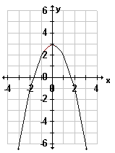What is an equation of the function shown in the diagram?
2. *y* = *x*2 + 3
3. *y* = -*x*2 + 3
4. *y* = -*x*2 – 3
5. *y* = (*x* - 3)2

Find the turning point :

So seriously, its facing down because a is negative.

1. What is the solution set of the equation 2*x*2 – 13*x* + 15 = 0? Use second trace.

These roots are rational

1. {–5, $\frac{-3}{2}$} 3. {5, $\frac{3}{2}$}
2. {$\frac{-3}{2}$, 5 } 4. {$\frac{-3}{2}$, -5 }

[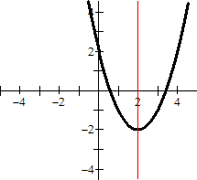](http://www.google.com/url?sa=i&rct=j&q=&esrc=s&source=images&cd=&cad=rja&uact=8&ved=2ahUKEwitsc6l-K_aAhXoYN8KHQcrDF4QjRx6BAgAEAU&url=http://www.mathwords.com/a/axis_symmetry.htm&psig=AOvVaw0vEfwv28Bpv9BhPOg1U_AZ&ust=1523457685926032)3) The axis of symmetry for the below parabola is:

1. $x=2$

2. $x=-2$

3. $y=2$

4. $y=-2$

Does it have a min or max? why?

1. What is the vertex of the equation algebraically:

*x*2 – *x* – 2 = 0?

1. (1,-1)   3. ( $\frac{1}{2} ,$- $\frac{9}{4} )$
2. (-1,1) 4.   (- $\frac{9}{4}, \frac{1}{2} )$
3. Which of the following equations has *both* 7 and -1 as its solutions? Solutions are opposite to factors


$(x+7)(x+1)=0$

$(x-7)(x-1)=0$

$(x+7)(x-1)=0$

$(x-7)(x+1)=0$

7. Which of the following equations in vertex form represents completing of the square of *y* = 3*x*2 + 6*x* - 9? Check graphically using Y 1 and Y 2. No work needs to be showen.
8. *y* = 3(*x* + 1)2 + 4
9. *y* = (3*x* + 3)2 - 12
10. *y* = 3(*x* + 1)2 - 12
11. *y* = 3(*x* + 1)2 – 4
12. Which expression is a solution for the equation 2*x*2 – *x* = 7? Look at the choices, most likely you will need the quadratic formula for this. These roots are irrational
13. https://www.castlelearning.com/Review/Courses/algebra/q1373-001.gif?v=20020530124212
14. https://www.castlelearning.com/Review/Courses/algebra/q1373-002.gif?v=20020530124224
15. https://www.castlelearning.com/Review/Courses/algebra/q1373-003.gif?v=20020530124232
16. https://www.castlelearning.com/Review/Courses/algebra/q1373-004.gif?v=20020530124244
17. If The values of a, b, c are: remember what standard form of a quadratic equations looks like.



$a=2 b=-1 c=-4$

$a=-2 b=1 c=4$

$a=2 b=1 c=4$

$a=-2 b=-1 c=-4$

22. If Maya completes the square for

*f*(*x*) = *x*2 - 6*x* + 13 in order to find the minimum, she must write *f*(*x*) in the general form

*f*(*x*) = (*x* - *a*)2 + *b*. What is the value of *a* for *f*(*x*)? Complete the square first and then you are on your own. Lol.

1. 3
2. -3
3. 13
4. -6
5. A possible function for the cube function is: use the graphing calculator.

1.

2.

3.

4.

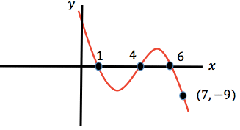

11. Given two consecutive positive integers have a product of 132.

* 1. Write an equation that can be used to find the integers.

Let n = 1st integer

Let n + 1 = second consecutive integer.

* 1. Find the integers algebraically by any method: if you want my advice, factor it.

Now pick only the positive solutions:

12. The width of a rectangular window is w. the length is $7$ more than the width. the area of the window is 44

1. Write an equation that can be used to find the width of the window.( Look at the last lesson please)
2. Solve the equation algebraically by any method.(If you want my advice, use the quadratic formula just for the fun of it.)

13.A rock is thrown from the top of a tall building. The distance, in feet, between the rock and the ground t seconds after it is thrown is given by $d = -16t^{2}+80t +220.$

1. Sketch the parabola and show appropriate window used. First look at your table and work on y max most likely. Also, a word problem requires time at 0 which means x min should be set at 0.
2. After how many minutes does the rock reaches the maximum height? What’s the height include units please?

Did you label your graph?

1. When does the rock hit the ground? It means to find the zeroes of the quadratic. I say, do it graphically!!
2. Find the time it will take the rock to get to that maximum height algebraically. Alright, I know it’s that beautiful axes of symmetry EQUATION that starts with x again. You better know what that is.

14. One more time, seriously!

|  |  |
| --- | --- |
| 1. By the Quadratic Formula: Describe the nature of the roots | 1. By completing the square. Your fav |

HW Review Questions just in case you didn’t have enough. Keep going, you can do it.

1. Which is a factor of *x*2 + 5*x* – 24?
2. (*x* + 4) 3. (*x* – 4)
3. (*x* + 3) 4.  (*x* – 3)
4. One of the factors of 4*x*2 – 9 is
5. (*x* + 3) 3. (2*x* + 3)
6. (4*x* – 3) 4. (*x* – 3)
7. Factor: $2x^{2}- x-3$
$(2x-3)(x +1)$

$(x-1)(2x-3)$

$(2x + 1)(x-3)$

$(x-1)(2x-3)$

9. Written in simplest factored form, the binomial 2*x*2 – 50 can be expressed as
10. 2(*x* – 5)(*x* – 5)
11. 2(*x* – 5)(*x* + 5)
12. (*x* – 5)(*x* + 5)
13. 2*x*(*x* – 50)
14. Which is an irrational number?
15. https://www.castlelearning.com/Review/Courses/integratedalgebra/sqrt-9.gif?v=20020726055222 3. 3.14
16. https://www.castlelearning.com/Review/Courses/integratedalgebra/sqrt-3.gif?v=20010802020050 4. https://www.castlelearning.com/Review/Courses/integratedalgebra/three-fourths.gif?v=20020502093208
17. What is imageexpressed in simplest radical form?
18. 2image 3.  3image
19. 6image 4.  8image

8) The expression $\sqrt{27}+ \sqrt{12}$ is equivalent to

1. 2.

3. 13 4.

9) The domain for $f\left(x\right)=x^{2}-3$ is 0 < *x* < 4. The range of f(*x*) is

1. 2.

3. 4.

10) If , find the value of f(3).

1. 1 2. 10

3. -5 4. 13

1. 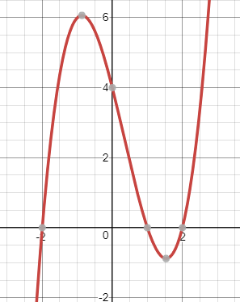Find the zeros of the following cube functions:

$x^{3}+5x^{2}+6x=0$